
FIR Project

Objective
A heterodyne communication system is designed that oversample samples the IF signal at a rate of f_{s} Sa/s. You are designing a baseband communication filter (FIR) that is used to recover a signal whose bandwidth is 0.15f_{s}. Specifically you are to design a set of 31st order lowpass linear phase FIRs that has a normalized passband frequency edge at ϖ_{p}=0.3π, stopband beginning at ϖ_{s}=0.4π, and an arbitrary transition band (don’t care). The design specifications are graphically interpreted below on a normalize frequency axis.
00.1π0.2π0.3π0.4π0.5π0.6π0.7π0.8π0.9ππ
ϖ
1.0
0.9

0.1
0.0
|H(e^{jϖ})|
Typical response
Don’t care
You will individually conduct multiple design attempts (Window, LMS, and Equiripple) and report, for each design and report, for each instance:
l₁, l₂, and l∞ frequency domain errors:=_________
l_{p}: 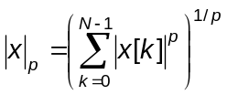; l∞ = max(x)
Maximum/minimum passband gain (linear/dB):=_________
Maximum/minimum stopband attenuation (linear/dB):=_________
Group delay predicted and measured (in delay units)=_________
Worst case gain G: =_________
Ratio of maximum to minimum non-zero coefficient: =_________

PART 1: Window Method
- Windowed FIR designs are supported with MATLAB’s fir1 and fir2 functions (remember to correct for MATLAB FIR order specification). Produce a 31st order FIR using the window method. Chose the most appropriate fir1 or fir2 operator to synthesize an FIR with a uniform window that meets specifications. Graphically display the impulse response, magnitude frequency, group delay, and the zero locations of your FIR.
- Repeat Part (a) using a Hamming window. Explain any major differences.
- Assume that the input is unit bound. Repeat part (a) using an 8-bit fixed-coefficient overflow free version of your filter. Explain any major differences.

PART 2: LMS Method
- Produce a 31st order LMS FIR solution that meets the original design specifications using MATLAB’s firls, fircls, or fircls1 LMS functions. Chose the most appropriate fir1 or fir2 operator to synthesize an FIR with a uniform window that meets specifications. Graphically display the impulse response, magnitude frequency, group delay, and the zero locations of your FIR.
- Repeat Part (d) using a Hamming window. Explain any major differences.
- Assume that the input is unit bound. Repeat Part (d) using an 8-bit fixed-coefficient overflow free version of your filter. Explain any major differences.

PART 3: Equiripple Method
- Design a 31st order linear phase lowpass equiripple filter, using uniform error weights, that meets the posted design specifications using MATLAB’s firgr, firpm, or gremez or other MATLAB function. Chose the most appropriate fir1 or fir2 operator to synthesize an FIR with a uniform window that meets specifications. Graphically display the impulse response, magnitude frequency, group delay, and the zero locations of your FIR.
- Repeat Part (g) using a Hamming window. Explain any major differences.
- Assume that the input is unit bound. Repeat Part (f) using an 8-bit fixed-coefficient overflow free version of your filter. Explain any major differences.
- Adjust the passband and/or stopband error weights to reduce the stopband attenuation by an additional 20%. Report the design output as before. In addition, graphically display the outcomes as overlays to the design completed in Part (f).

PART 4: Testing
- Test your equiripple (Part 3.a) output response to sinusoidal inputs at frequencies f₀=0.05f_{s} and f₀=0.15f_{s}. Measure the input-output phase delay.
- Test your equiripple Part 3.a) filter’s output response to a unit bound worst case input. Compare the outcome to the worst case gain prediction.

PART 5: Run-Time Architecture
Analyze your equiripple non-uniform weighted FIR as a fixed-point filter. Specifically study the performance of the FIR using a signed fixed-point arithmetic. For this study, the filter’s floating point response and coefficients will be assumed to be exact (truth). Assume the use of a Direct FIR architectures and the input bonded by unity (i.e., |x[k]|<1). The filter is implemented using the arithmetic unit shown. The filter’s input samples and tap weight coefficients (assuming that the tap weight coefficients are likewise bounded by unity) are rounded to N-bits (N-1 fractional bits of precision), for N=8, 12, and 16-bits. The supporting MAC is configured using an extended precision accumulator that has a wordwidth of N+M-bits where M is smallest integer that will insure run-time overflow-free performance. Choose the value of M for your FIR. Conduct simulation studies for the Direct architecture using a 10,000 samples of a uniformly distributed noise process bounded by unity. Plot the roundoff error (difference between fixed-point and floating-point) for each choice of N and M. Determine how many bits of fractional precision each of the tested architecture provides.
FIR MAC unit.
∗
∑
N
N
x[k-m]
h[k]
2N
2N+M
MAC
Round
N
y[k]

PART 6: Experimentation
You are to conduct an experiment using your FIR and specifications listed at the end of the Project narrative. Recall that the FIR was designed with a purpose, that being the design of a communications receiver. The specific application is a quadrature phase shift keyed (QPSK) system consisting of a transmitter and receiver. Each transmitted 2-bit symbol has one of four distinct values (S={0, 1, 2, 3}). Each symbol is coded as QPSK symbol having one of four phasors with magnitudes of 0.707 and orientations (±45°, ±135°), as suggested in the insert.
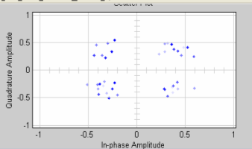
Insert: Noisy QPSK constellation.
Constellation
If the transmission filter had a passband given by f_{B}=0.25f_{s}, and additive noise is added to the transmission, the spectra, measured at the output of the transmitter and input to the receiver are shown below.

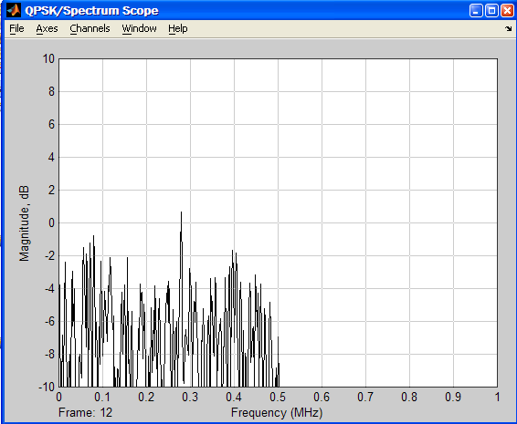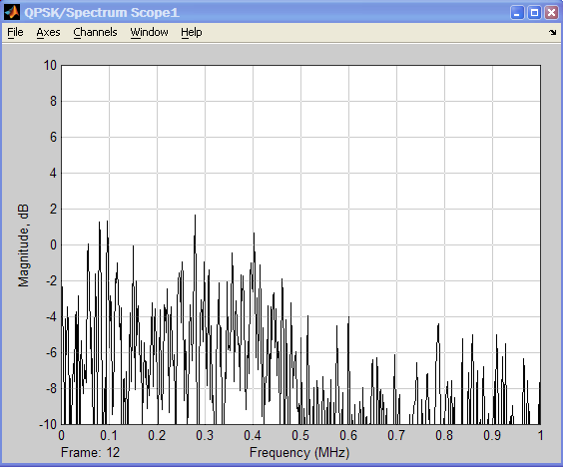
Transmitted (tx) spectrum (left), Received (rx) spectrum (right).
The communications receiver processes the transmitted signal and performs the needed decoding operations. The more noise is added to the signal, the association of a specific sample with a specific symbol becomes less certain and the bit error rate (BER) increases. Your assignment is to access your FIR filter as a receiver filter in order to reduce the BER.
Assume that the symbol rate is f_{QPSK}. Generate 10,000 symbols are randomly generated, and uniform noise is added to define the given SNR. Use MATLAB conv to filter the received signal. Use your knowledge of group delay to synchronize the FIR’s output with the known transmitted symbol. Measure the BER.

REPORT
The FIR project written reports are tentatively due before class on October 10, 2007. There is a 10-page limit to your report so use common sense. I do not want to see code. What I want to see are your crisp responses to each part of the FIR project. As with any good report I expect to see the following items (provided as guideline):
Executive Summary (high level overview, maximum 100 words)
Statement of the Problem
Study Plan
Discussion of Results (Main body)
Summary
References/Bibliography
Project will be submitted as a hardcopy on the due date (or before). No email submissions will be accepted.
On October 10, there will also be group presentations. More about this later!
Part 6 Filter Assignments:
No. | Type (with rectangular) | Weighted | SNR | Symbol rate | BER (tbd)
1 | Equiripple | No | 10 | f_{QPSK} = 0.125f_{s}
2 | Equiripple | Yes | 10 | f_{QPSK} = 0.125f_{s}
3 | Equiripple | No | 0 | f_{QPSK} = 0.125f_{s}
4 | Equiripple | Yes | 0 | f_{QPSK} = 0.125f_{s}
5 | Equiripple | No | 10 | f_{QPSK} = 0.25f_{s}
6 | Equiripple | Yes | 10 | f_{QPSK} = 0.25f_{s}
7 | Equiripple | No | 0 | f_{QPSK} = 0.25f_{s}
8 | Equiripple | Yes | 0 | f_{QPSK} = 0.25f_{s}

Filter | Last Name | First Name | User ID
1 | Adeladan | Oluwatosin | atosin
1 | Ahmad | Syed | sowaiahmad
1 | Anne | Niharika | nianne
1 | Balaga | Siva | balagasat
1 | Bibikar | Salil | sbibikar
1 | Chen | Jikai | yfgchen
1 | Chen | Qian | qiantrue
1 | Chinta | Raviteja | ravitejac
2 | Deshmukh | Rucha | rdeshmukh
2 | Dougherty | Christopher | chrisdoc
2 | Fan | Yu | daisyfan
2 | Galloza | Hector | hgalloza
2 | Garcia | Rafael | ragarcia
2 | Gosrani | Kunal | kgosrani
2 | Graves | Eric | ericsgra
2 | Guan | Xin | guanxin
3 | Gundapuneni | Rahul | rahul1984
3 | Gupta | Gunjan | gunjangupta
3 | Haile | Mulugeta | mhaile
3 | Hasanbelliu | Erion | erioni
3 | Hett | Christopher | littlema
3 | Hollensen | Christopher | cholnsn
3 | Irby | Geoffrey | geezncol
3 | Iyer | Arvind | arvindr100
4 | Iyer | Neeleshwar | niyer2
4 | Kalidindi | Kiran | kkiranvarma
4 | Karwacki | Robert | robol
4 | Keen | Sara | maxpower
4 | Kia | Behnam | behnam.kia
4 | Leng | Jiadi | lengjiadi
4 | Li | Baolong | f19850325
4 | Lughmani | Taha | tahalughmani
5 | Magapu | Raghu | raghu22
5 | Mathur | Megha | megha.mathur
5 | Mcintee | Robert | balios
5 | Meyer | Christopher | toph
5 | Misas | Orlando | omisa001
5 | Mulvaney | Brian | mulvaney
5 | Panjwani | Rishi | rrishi
5 | Parkinson | Alexander | okalex
6 | Potluri | Sindhu | cindy27
6 | Pottim | Karunakar | kpottim
6 | Ramakrishnan | Padmanabhan | padmanabhanr
6 | Rao | Yuan | yrao1
6 | Richardson | Justin | jstrds
6 | Sen | Tilottama | tiltsen
6 | Shah | Pranali | pranali.shah
6 | Sharma | Mayank | mav1984
7 | Singh | Chandni | chandni.singh
7 | Singhal | Surbhi | surbhisinghal
7 | Sishtla | Venkata | divyamadhuri
7 | Sooryanarayanan | Padma | s.padma
7 | Sun | Jingjing | sunjingjingmia
7 | Talloju | Karthik | karthik.t
7 | Thota | Aditya | aditya.thota
7 | Vardhan | Avantika | avardhan
8 | Varghese | Reno | renovar707
8 | Venkatachari | Balaji | bvk
8 | Wang | Tong | t.wang
8 | Williams | Jason | jason.d.williams
8 | Yan | Yan | swallow314
8 | Yang | Yan | kathyyang
8 | Yu | Xiaogang | xyu

